**Abstract**

**Background**: COVID-19 has disproportionately affected vulnerable populations across the United States. Regional-level analyses are critical to understanding local drivers of severe disease and mortality.

**Objective**: To describe the determinants and clinical distribution of COVID-19 cases in Brazos County, Texas (2020–2022), and identify factors associated with hospitalization and death.

**Methods**: We conducted a cross-sectional study using surveillance data of confirmed COVID-19 cases. Variables included age, sex, race, travel history, symptom presence, hospitalization, and death. Logistic regression was used to estimate adjusted odds ratios (ORs) and 95% confidence intervals (CI) for factors associated with hospitalization and death.

**Results**: Of 3,221 complete cases, older age was the most significant predictor of hospitalization and death. Individuals aged 65+ had 85 times greater odds of hospitalization (OR=84.95, 95% CI: 54.30–132.88) and over 800 times greater odds of death (OR=831.29, 95% CI: 115.10–5999.99) compared to those aged 18–24. Black and Hispanic patients had higher odds of severe outcomes, while females and individuals with a travel history had lower odds.

**Conclusion**: Advanced age and racial disparities were key determinants of severe COVID-19 outcomes in Brazos County. Targeted public health interventions are needed to protect high-risk groups during future outbreaks.

# Tables for Manuscript

## Table 1. Descriptive Characteristics of COVID-19 Cases by Hospitalization Status

This table summarizes the demographic and clinical characteristics of COVID-19 cases in Brazos County, Texas (2020), stratified by hospitalization status.

|  |  |  |  |  |  |  |  |  |
| --- | --- | --- | --- | --- | --- | --- | --- | --- |
| Hospitalized | Age_mean | Age_std | AgeGroup_<lambda> | Sex_clean_<lambda> | Race_clean_<lambda> | Traveled_<lambda> | Symptoms_present_<lambda> | Died_<lambda> |
| 0.0 | 31.00 | 17.22 | {'18-24': 5088, '25-39': 2387, '40-64': 2372, '0-17': 1117, '65+': 685} | {'F': 6201, 'M': 5448} | {'W': 5148, 'H': 3592, 'Unknown': 1464, 'AA': 1007, 'Other': 436, 'w': 1, 'unknown': 1} | {0: 9887, 1: 1762} | {1: 11467, 0: 182} | {0.0: 11618, 1.0: 31} |
| 1.0 | 63.22 | 19.43 | {'65+': 219, '40-64': 155, '25-39': 38, '18-24': 14, '0-17': 3} | {'M': 217, 'F': 212} | {'W': 168, 'H': 157, 'AA': 83, 'Unknown': 14, 'Other': 7} | {0: 383, 1: 46} | {1: 380, 0: 49} | {0.0: 332, 1.0: 97} |

• Compares age, sex, race, symptoms, and outcomes between hospitalized and non-hospitalized patients.

• Hospitalized patients were older and more likely to be Black or Hispanic.

## Table 2. Adjusted Odds Ratios for Hospitalization Among COVID-19 Patients

This table presents adjusted odds ratios (OR) and 95% confidence intervals (CI) from logistic regression for factors associated with hospitalization.

|  |  |  |  |
| --- | --- | --- | --- |
| Variable | Adjusted OR | 95% CI | p-value |
| Age 25–39 vs 18–24 | 6.25 | 3.91 – 9.99 | <0.0001 |
| Age 40–64 vs 18–24 | 19.68 | 12.67 – 30.56 | <0.0001 |
| Age 65+ vs 18–24 | 84.95 | 54.30 – 132.88 | <0.0001 |
| Race: Black vs White | 3.04 | 2.28 – 3.89 | <0.0001 |
| Race: Hispanic vs White | 1.63 | 1.31 – 2.03 | <0.0001 |
| Travel History | 0.58 | 0.38 – 0.90 | 0.0135 |
| Sex: Female vs Male | 0.85 | 0.71 – 1.01 | 0.0649 |
| Race: Other vs White | 0.77 | 0.42 – 1.39 | 0.3845 |

• Strong **predictors**: Age ≥65 (OR: 84.95), Black race (OR: 3.04), Hispanic ethnicity (OR: 1.63).

• Protective **factor**: Travel history (OR: 0.58).

## Table 3. Adjusted Odds Ratios for COVID-19 Related Deaths

This table presents adjusted odds ratios (OR) and 95% confidence intervals (CI) from logistic regression for factors associated with death due to COVID-19.

|  |  |  |  |
| --- | --- | --- | --- |
| Variable | Adjusted OR | 95% CI | p-value |
| Age 25–39 vs 18–24 | 17.08 | 2.20 – 132.42 | 0.0066 |
| Age 40–64 vs 18–24 | 114.99 | 15.92 – 829.78 | <0.0001 |
| Age 65+ vs 18–24 | 831.29 | 115.10 – 5999.99 | <0.0001 |
| Sex: Female vs Male | 0.69 | 0.51 – 0.93 | 0.0158 |
| Race: Black vs White | 2.05 | 1.33 – 3.16 | 0.0012 |
| Travel History | 0.38 | 0.15 – 0.93 | 0.0340 |
| Race: Hispanic vs White | 1.38 | 0.96 – 1.99 | 0.0835 |
| Race: Other vs White | 0.91 | 0.33 – 2.54 | 0.8596 |
| Race: Unknown vs White | 0.24 | 0.11 – 0.55 | 0.0008 |

• Strongest **predictor**: Age ≥65 (OR: 831.29).

• Other **factors**: Female sex protective (OR: 0.69); Black race at increased risk (OR: 2.05); travel history protective.

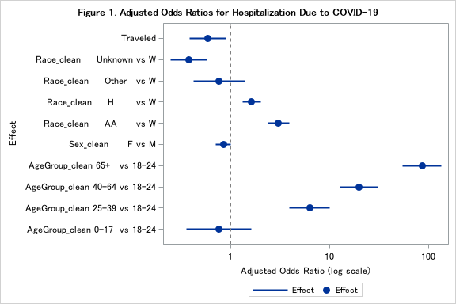

**Figure 1 – Forest Plot: Hospitalization Model**

* Visual representation of adjusted ORs with 95% CIs for predictors of hospitalization.

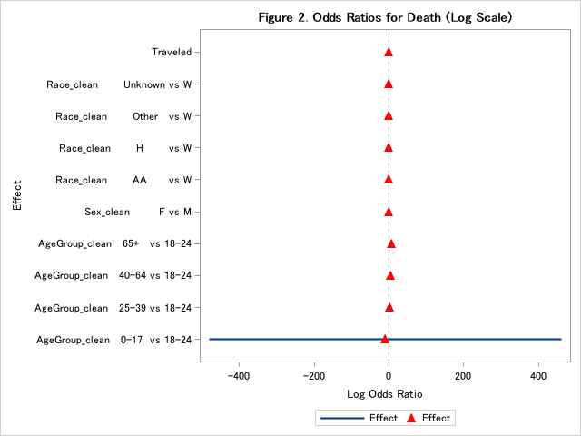

**Figure 2 – Forest Plot: Death Model**

* Highlights extreme risk increase with age and disparities by race.

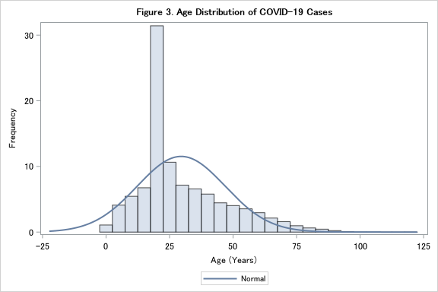

**Figure 3 – Age Distribution Histogram**

* Shows bimodal distribution with peaks in younger (college-age) and older adults.

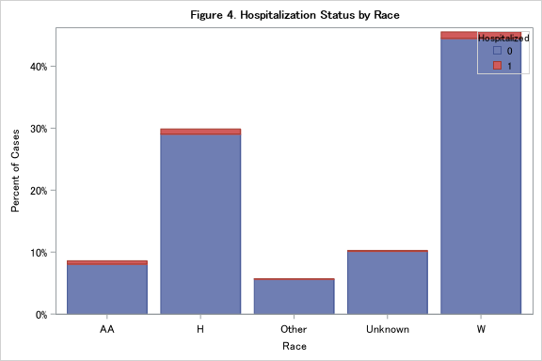

**Figure 4 – Hospitalization by Race (Stacked Bar)**

* Visualizes racial disparities in hospitalization rates.

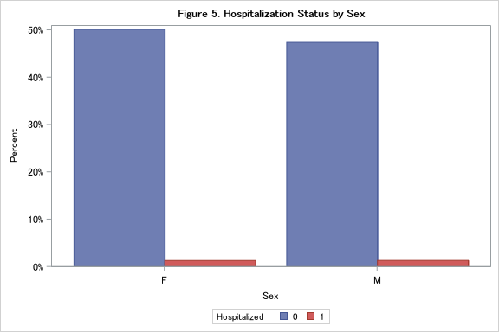

**Figure 5**: Grouped bar – Hospitalization status by sex.